Web Reports – Incompatible Browser
Issue:
When trying to get into Web Reports, you may come across an error which says “Sorry, incompatible browser” (see below).
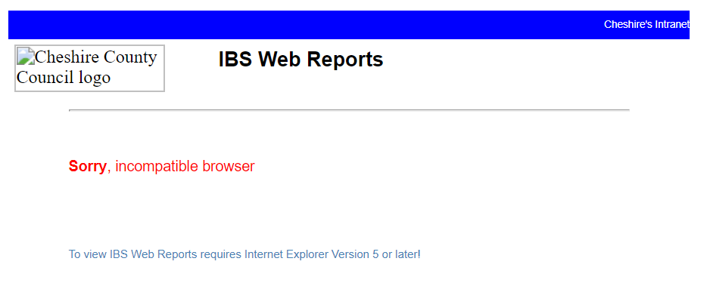

Resolution:
To resolve the issue, ensure that you’re in Internet Explorer, and then:
1. Click on the cog in the top right of the screen (next to the star/favourites icon)
2. On the list that appears, click "Compatibility View Settings" which is third from bottom of the list.
3. In the box which has “Add this website:” over it, type in "cccusers.com" and then click “Add” – this will then add the website to the list of "Websites you've added to Compatibility View".
4. Close and re-open Internet Explorer, then try to access the relevant web reports again. This will now allow you to access.

