Student photographs to Excel – instructions

Create a report in SIMS which includes the “Photo” field
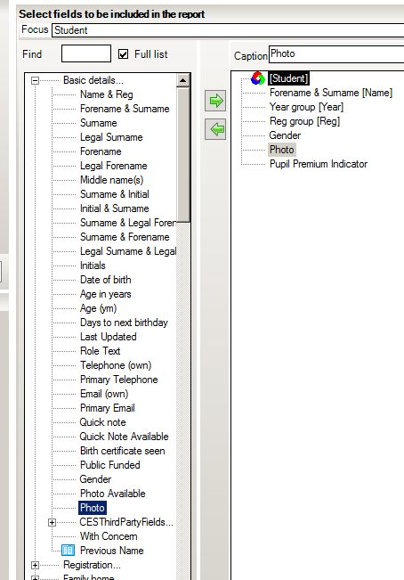
The output must be Text and XML (with no schema). Specify the file name and where it will be saved.
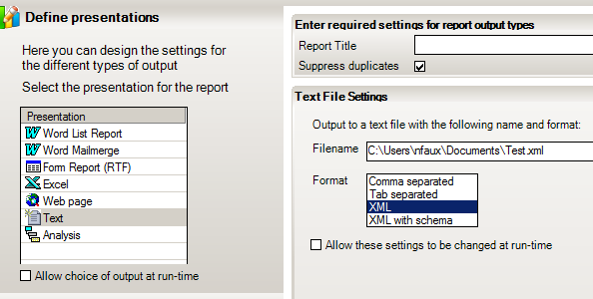

Before running the report, please contact the SIMS helpdesk to request the following file:
“Picture_convertor_2.xlsm”

*Once requested, please follow the remaining steps below: *
Open Picture_convertor_2.xlsm
Click on the “Convert” button.
Browse to the .XML file.
Accept default “As an XML table” if it asks how you would like to open the file and OK the message: “The specified XML source does not refer to a schema. Excel will create a schema based on the XML source data”.
If your photographs are too big you may get a further message about truncation, but it should not stop the import.
Select how you want the pictures to be added and click OK.
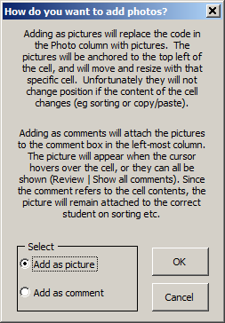
The file it creates may be quite large. Consider compressing the pictures when you save (Tools | Compress Pictures)
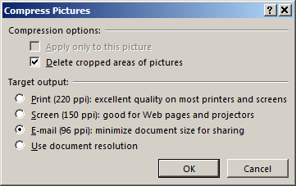

NF 09/02/2018

