Creating EYFS Baseline CTF
To create EYFS Baseline CTF - Go to:
Routines\Data Out\CTF\Export a CTF
Highlight “General” and click Select

Remove all ticks from boxes except “Standard basic details”
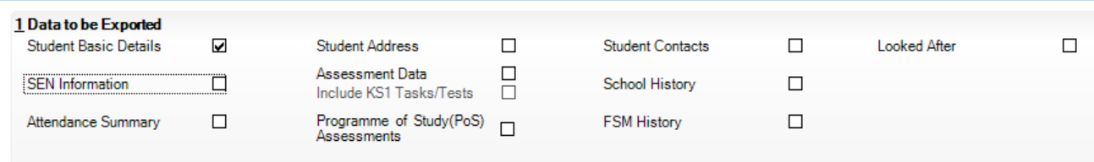

In Student section, click on dropdown next to Year Grp.
Click on “R” to select only reception Pupils
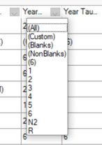

Click the top Pupil to highlight, then scroll down to bottom of the list.

Hold down “Shift Key” and click on bottom pupil to highlight all pupils.
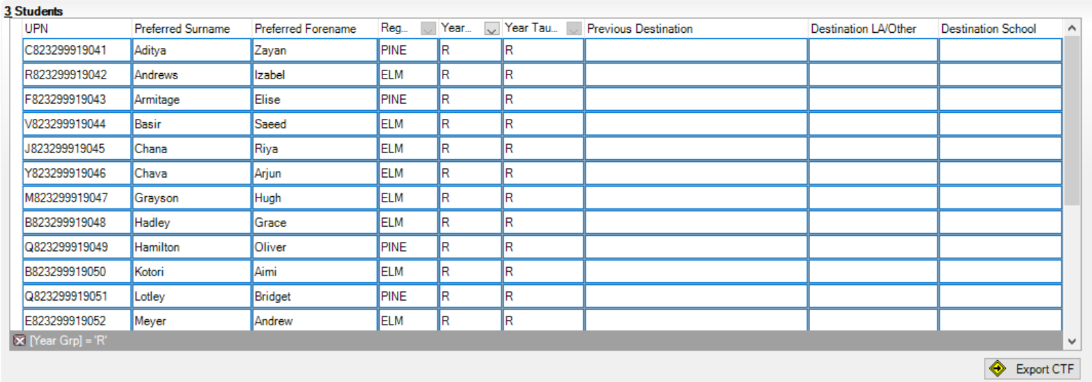

Carefully click on right hand side of last cell in “Destination School” and select your own school

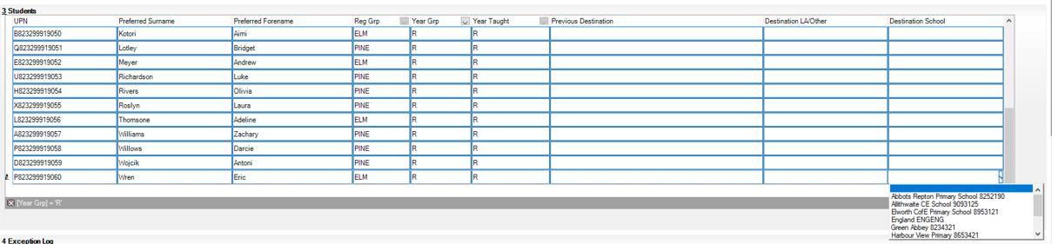
This should now flood fill all pupil’s destination.
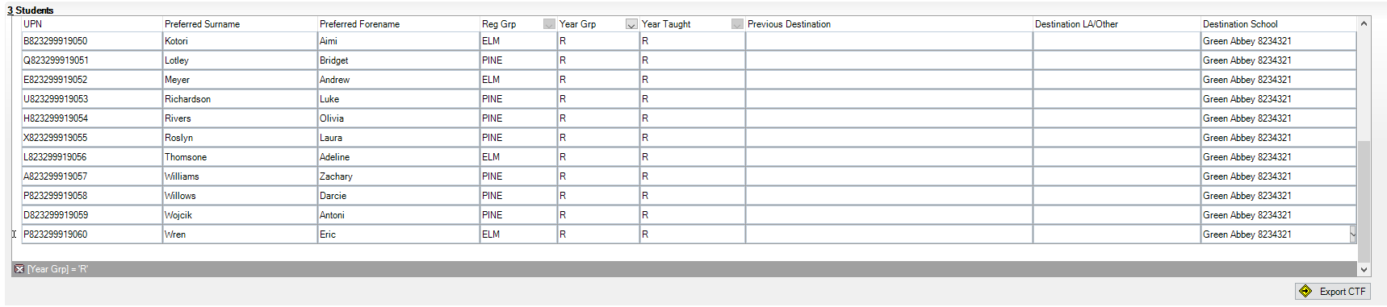
To finish Click on “Export CTF” to create required CTF

