Leavers still showing in Sims

IMPORTANT: Whenever making a pupil(s) a leaver you must use Leaver Routine in Sims.

Routines\Pupil\Leavers

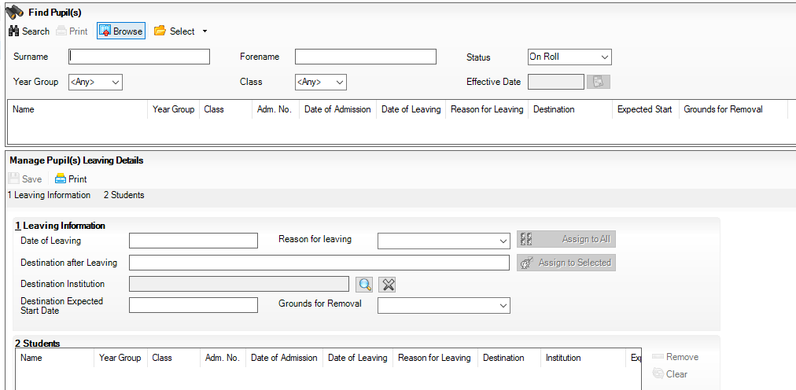

Failing to use this routine can mean that in certain sections of Sims and in some reports, pupils that you have made leavers will still show.

If after using this routine pupil is still showing, then run the following in Sims.

- Database Diagnostics

Go to - Tools\System\Diagnostics\Database Diagnostics

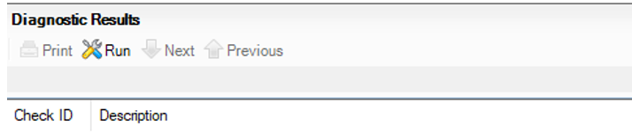

Click on Run
Then “Yes” to next message
This can take between 5 to 20 minutes to rune depending on number of pupils.

When completed it will show results from 100 checks
Scroll down list and look at any relevant highlighted sections that refer to attendance.
This will hopefully show correction for any leavers still showing on roll.
- Validate membership

Go to - Tools\Validate Membership

Click OK
This will only take a few minutes to run.

- Student still showing as an Applicant in Admissions.

If after doing all of this pupil still shows the reason for this could be that pupil is still showing as an applicant.

Note: Some report will show on roll pupils as well as “Accepted Applicants”

To check this, go to.

Focus\Admission\Application

Make sure all relevant field selections are set to “Any” and click search.
If pupil showing, then highlight and click on delete (red cross) to remove.

