Phonics 2020 Creating Marksheet
To create a Phonics marksheet for teachers to apply Year 1 grades for Year 2 pupils select the following:
Tools\Performance\Assessment\Wizard Manager
Select “Year 1 Phonics Screening Wizard 2020”
Then click Next…
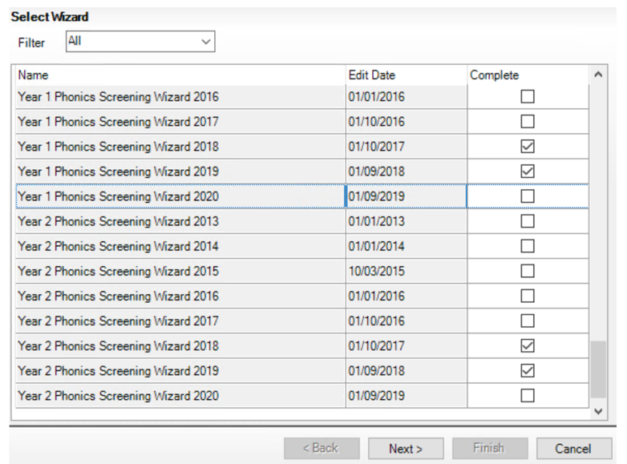

Click on Magnifying Glass
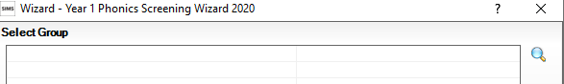

And select Year 2
Then click on Apply
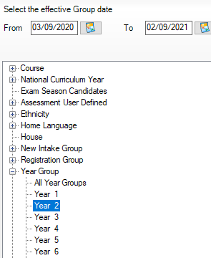
Click Next
Click on Phonics Screening Year 1 2020 template to highlight
Then click on Green pencil to open Marksheet
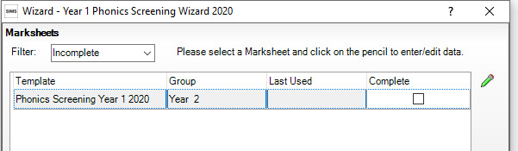

If you need to confirm you have Year 2 Pupil
Right click in box titled “Students”
And click on “Select Additional Student columns”
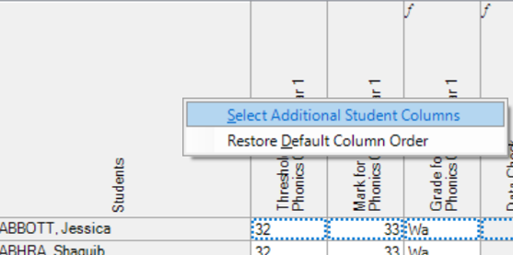

Put tick in National Curriculum Year
Then click OK
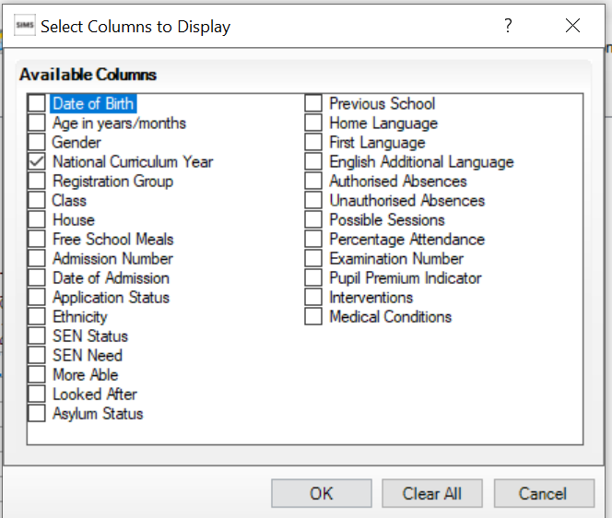

Marksheet will show column next to Name with pupil’s current year group (2)
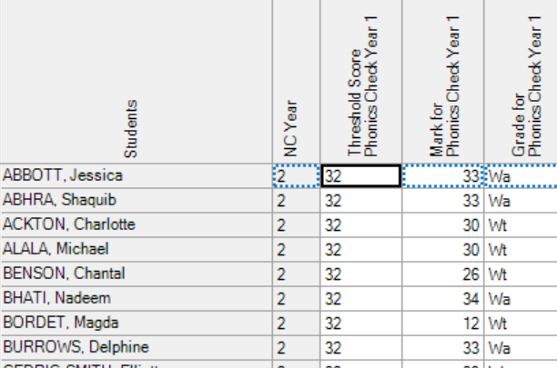

Right Click on Column “Threshold Score” and select 32

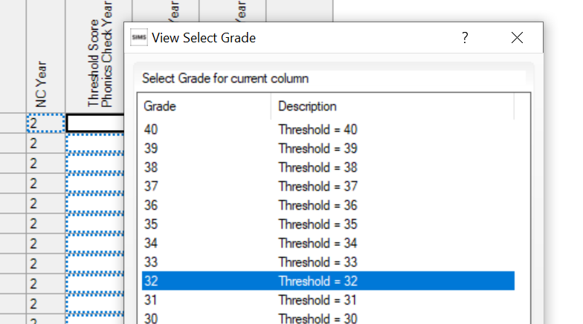

Column will populate with correct threshold mark of 32
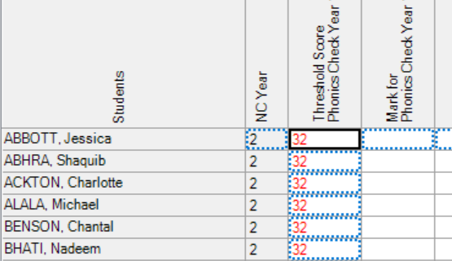

You then need to fill in Marks column with Pupils individual mark (0 – 40)
Once completed click on calculate to auto populate Grade Column (wt – wa)

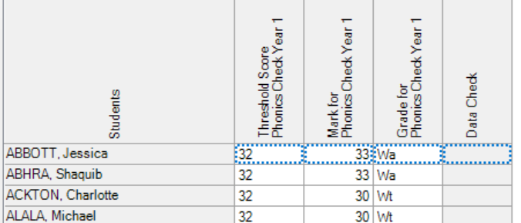

Now marksheet is completed click on “Save” and close marksheet.

Printing Results (if needed)
Once marksheet complete, you can move to next area of the wizard by clicking “Next” to allow you to print either individual reports or Comparative reports
Individual Reports
Simply tick box next to pupil’s names.
Highlight “KS1 Y1 Phonics Student Eng 2020.
You have 4 Icons on the right which give you different report output options.
The top icon lets you preview reports.
The second icon print reports.
The third option Exports all the report to a location of your choice.
The fourth (bottom) uploads all report to pupils linked documents area.

Comparative Report
Simply need to have one pupils tick box ticked to run report
Highlight “KS1 Y1 Phonics Comparative Eng 2020
The choose any of top 3 Icons to print

