Student Analysis reports

Student Analysis report will allow you to show numbers of pupils at any time past or present
To run reports, go to
Reports\ Student Analysis report
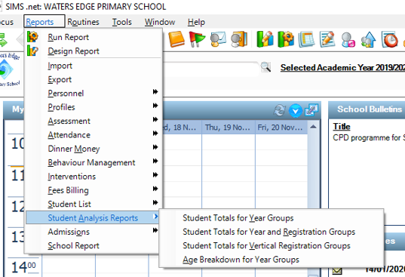

There are 4 reports to choose from:
The first 3 reports.
- Student totals for year groups
- Student totals for year groups and reg groups
- Student totals for vertical reg groups

Will all prompt you to select Effective (on roll) date to return correct figures

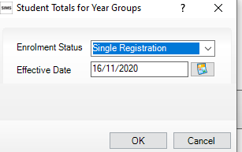

The fourth report
Age breakdown for year groups will prompt for
Effective Date (Student on roll at that date)
Reference Date (What were their ages as at this date)
Upper & Lower Age limits

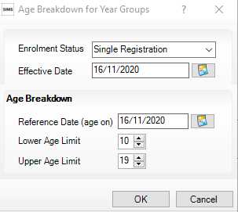

Set Enrolment Status.
Effective date (On roll as of date)
Reference date (What were their ages as at this date)
Lower age limit
Upper age limit

